Boodey Images
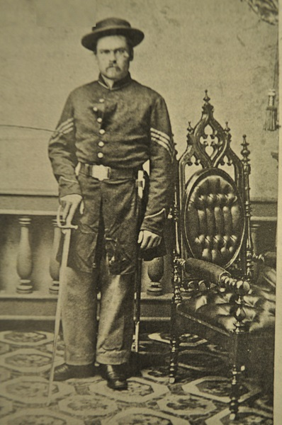
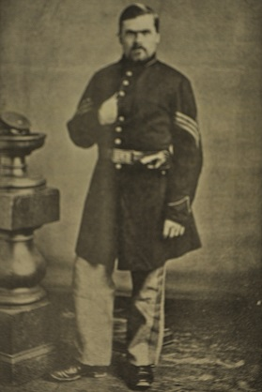
Sergeant Levi Barker Boodey

Questions: What about Levi Boodey’s unifom indicates that he was a sergeant in the Union Army? What other accessories or insignia carry military meaning? Which picture do you believe came first? Why?
Levi Boodey’s older brother, store owner Merrill Boodey
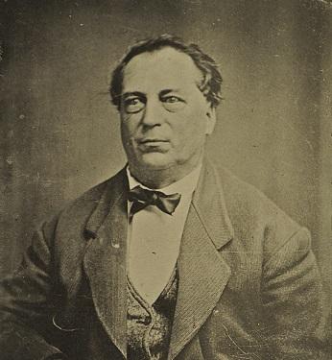
Questions: What does Mr. Boodey’s dress and pose indicate about his role in Peninsula business and politics? In making his voting decision in the 1864 presidential election, how might he balance his feelings about his younger brothers’ service in the Union army with his well known Democratic points of view?

Levi Boodey’s sister-in-law, wife of Merrill Boodey, Martha Thompson Boodey
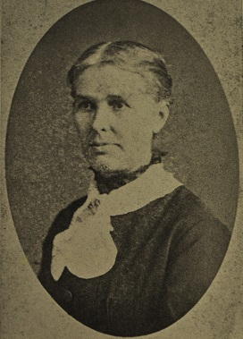
Question: Why do you think Sergeant George Boodey wrote more to his sister-in-law than to his older brother during his time in military service? What do you think Martha Boodey would have advised her husband Merrill about his politics and his business in consideration of Sergeant Boodey’s letters?
Merrill Boodey’s Store on Main Street, Peninsula was just past the bridge and next to the Cuyahoga River. It was the site of many public gatherings and political debates including one imagined in the “Peninsula Politics” optional reading in “Setting the Stage”.
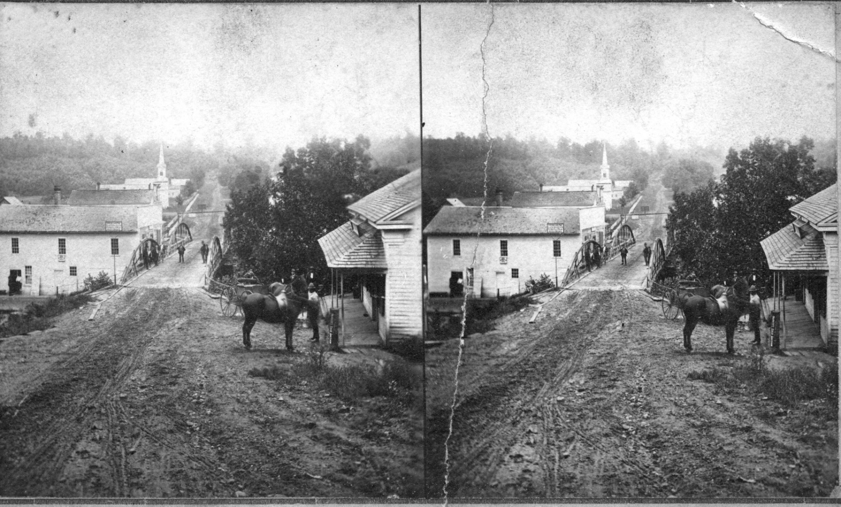
Question: Sergeant Boodey wrote home often about coming home and plans for after the war. While much advice about this was exchanged between Merrill and Levi, Levi never spoke of coming home to work in Merrill’s store? Why not do you suppose?
The Merrill Boodey Family home on Main Street, next to the Peninsula and Boston Township Town Hall
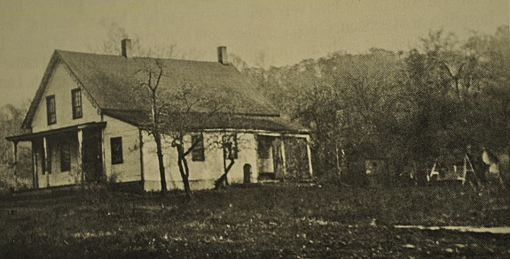
Question: What does this homestead show about the Merrill Boodey family’s standard of living? How does the Merrill Boodey homestead compare with that of Lawson Waterman?

